

Items highlighted in yellow are tasks for you to complete
Items in Blue are help tip

Introduction to Mail Merge

Mail Merge is the term given to the process where we start with a main document and a set of details, the data source, about customers, suppliers, members etc. We “merge” the two together to produce a set of documents individualised for each customer, supplier etc. This process is more efficient than individualising each document with details one at a time.

Another advantage is that the data source can be used repeatedly for various documents. In the example shown below the same data has been used to produce individualised documents regarding a change of phone number, and then to produce name labels.
Main Document

Company

Dear Customer,

We write to advise that our new phone number is

123 456 789

We look forward to hearing from you.

Yours sincerely

Manager
Silly Billy Pty Ltd

Dear Sally,

We write to advise that our new phone number is

123 456 789

We look forward to hearing from you.

Yours sincerely

Manager
Slim Pickings Pty Ltd

Dear Fred,

We write to advise that our new phone number is

123 456 789

We look forward to hearing from you.

Yours sincerely

Manager
Blitz Pty Ltd

Dear Jim,

We write to advise that our new phone number is

123 456 789

We look forward to hearing from you.

Yours sincerely

Manager
Cranky Pty Ltd

Dear Anna,

We write to advise that our new phone number is

123 456 789

We look forward to hearing from you.

Yours sincerely

Manager
Data Source

Company | First name | Surname
Silly Billy Pty Ltd | Sally | Bally
Slim Pickings Pty Ltd | Fred | Bare
Blitz Pty Ltd | Jim | Lim
Cranky Pty Ltd | Anna | Ray

Main Document
Labels

Name
Company

Merged Document Labels

Jim Lim
Blitz Pty Ltd
Sally Bally
Silly Billy Pty Ltd

Anna Ray
Cranky Pty Ltd
Merged Documents
Fred Bare
Slim Pickings Pty Ltd

In this section you will

- Create the Main document
- Create a Data Source
- Merge a Main document and Data Source
- Use an existing Data Source for the merge
- Maintain a Data Source
- Create Mailing Labels

Create the Main Document

The first requirement of a Mail Merge is a main document. The main document consists of the general information that will go to all recipients.

- Enter the following text, it will be the main document.

Big Top Events

Dear

Re : The Big Show

We are pleased to offer you the opportunity to again take part in this prestigious event.

The Big Show is scheduled to occur on the last weekend in May, Friday May 27th to Sunday May 29th.

We look forward to confirming your participation. If you require further details please don’t hesitate to contact my assistant, Zepo, on (03) 1234 5678.

Yours truly

Bozo Clowning
Marketing Director
Big Top Events

- Save the file as Big Top on your disk

Start the Mail Merge Process

- Click on Tools ➢ Mail Merge in the Menu bar

The Mail Merge Helper will appear outlining the three main steps in the merge process

- Create the Document
- Get the Data
- Merge the Document and the Data

- Click on the Create button to display the different types of merge documents available

- Click on Form Letters
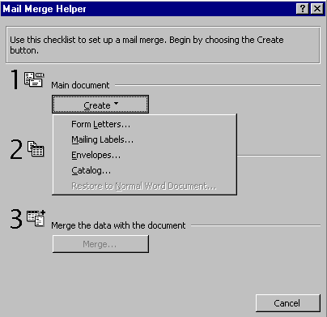
Form Letters
Create

The following dialog box appears to determine if the main document is open on the screen or if you want to create a new main document at this point.

- Click on Active Window – as we already have the main document displayed
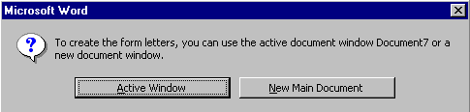
The Mail Merge Helper will remain on the screen ready for the next step Getting the Data.

Creating a Data Source

The Mail Merge Helper enables you to Create a Data Source that can be saved for later use and/or used immediately for the Mail Merge. We are going to Create a Data Source of Suppliers.

- Click on the Get Data button at Step 2

- Click on Create Data Source
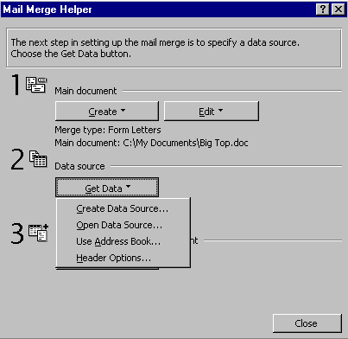

The Create Data Source dialog box will appear as shown on the following page.

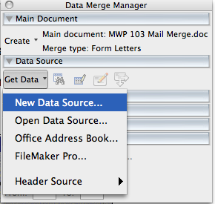
The Create Data Source dialog box will appear as below. We use this to determine the names of the fields we want included in each record. Word provides us with a list of commonly used fields that we can use. We must remove any that we don’t require.
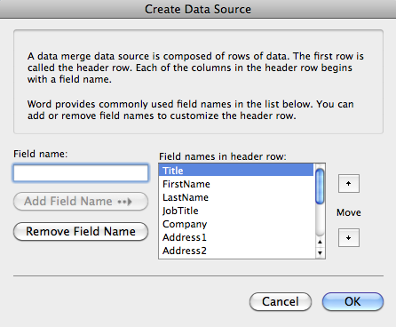
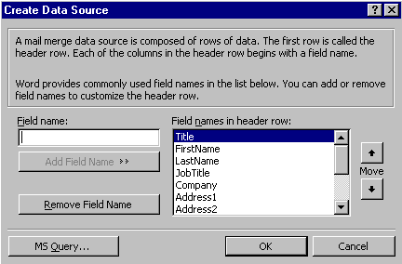

To Remove a Field from the List

We must remove any fields that are not required.

- Click on the field JobTitle

- Click on Remove Field Name

The field will be removed from the list. We require these fields only:

- Title
- FirstName
- LastName
- Company
- Address1
- City
- State
- PostalCode

- Remove the fields not required in the list (Address2, Country, HomePhone, Workphone)

- Click on OK when the list is complete

At this point the Save As dialog box appears as shown on the following page.

When the data fields have been chosen Word wants to save the data file. We save the Data Source as a separate file so it can be used with other main documents.

- Type Big Top Data in the File Name box

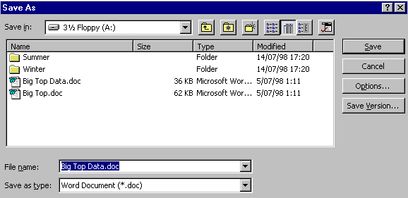
- Click on Save

When you click Save a message appears telling you that the Data Source does not yet contain any records (data). We are ready to put the data into the fields so…..

- 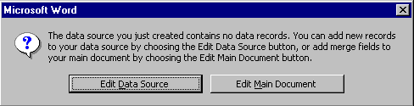Click on Edit Data Source

A blank Data Form window will appear ready for the data to be entered as shown on the following page.

The data can be entered through this form. The Data Form will be waiting for you to type an entry in the first field.

- Type MR in the Title field

- Press the [Tab] or [Enter] key to move to the next field
- Type Joh then press [Tab] or [Enter]
- Repeat for the remainder of the details in the record
- 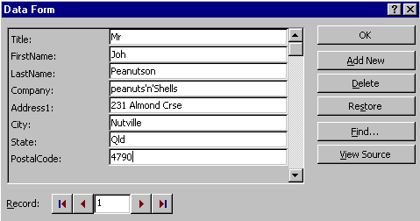When finished with PostalCode press [Enter] to move to a new record

- Enter the rest of the details as shown below

Title | First  Name | LastName | Company | Address | City | State | Postal code
Mr | Joh | Peanutson | Peanuts’n’Shells | 231 Almond Cres | Nutville | Qld | 4790
Ms | Ima | Hungary | Snakis  faction | 45 Milky Way | Fudgeville | Vic | 3289
Ms | Nikki | Tarna | Sultana Whizz | 59 Grape St | Vinetown | Vic | 3895
Ms | Honey | Bee | Sweet Snacks | 54 Sugar Street | Moreville | Qld | 4387
Mr | Sam | Toucan | The Breakfast Kings | 3 Branch Cres | Treeville | Vic | 3654

- Click on OK when all the data is entered to return to the Word workscreen

Merging a Document

When the Data source has been created the fields can then be inserted into the Main document. This step is to indicate to Word where to put the Data in the letter.

The Merge toolbar was activated when the data source was created.

With the Main document on the screen…

- Position the insertion point just below the letterhead

- Click on the Insert Merge Field button

- Select Title from the field list

- Press the [Space] Bar

- Click on the Insert Merge Field button and select First Name
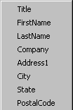
- Press the [Space] bar again

- Click on the Insert Merge Field button and select LastName

- Press [Enter]

- Repeat to enter the remaining fields as positioned below

Big Top Events

´Titleª ´FirstNameª ´LastNameª
´Companyª
´Address1ª
´Cityª ´Stateª ´PostalCodeª

Dear ´FirstNameª

Re : The Big Show

To Merge the Document and Data

When all required Merge fields have been entered the Main Document and the Data are ready to be merged. Before Merging it is useful to view what the merged documents will look like.

With the Main document, Big Top on the screen

- Click on the View Merged Data button on the toolbar
View Merged Data

The data will appear to be merged into the Main document. You can click through the letters that will be printed using the navigation buttons on the Mail Merge toolbar

First Letter
Last Letter
Current Letter

Previous Letter
Next Letter

The document and data can be merged to a new document or straight to the printer and printed. Merging to the printer is preferable (once you have checked each document for accuracy). There is a risk in merging to a document in that data may change from the time the merged document is created and when it is eventually used.
Merge to Printer
When ready to print…..

- Click on the Merge to Printer button

A letter for each record in the Data Source will be printed.

Managing a Data Source

Data Sources are valuable resources that can be used many times over. The Microsoft Word Data Source does not have the sophisticated capabilities of a full database, however you may find that a well designed data source fulfills your needs adequately for a variety of needs.

The Data Source File

Data Source files are saved as separate documents. The same data source can be used to create a variety of different Merge documents. For example, the same customer Data Source file can be used to send invoices, newsletters, advertisements, notifications, etc. As the Data Source file is stored in a table format, it can be sorted in a logical order, and used to add or delete records.

We usually do not see the Data Source file while we are working in Mail Merge. However we can look at the Data Source file easily by clicking on the Edit Data Source button. This will display the original Data Form that we used to enter the details in.
- Click on the Edit Data Source button
Edit Data Source

- The Data Form will be displayed
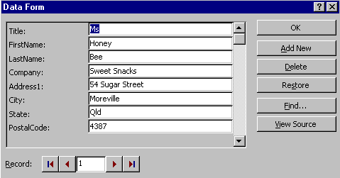

Add New Records

- Click on the Add New button to display a blank record

- Add three new records

Title | FirstName | LastName | Company | Address1 | City | State | PostalCode
Sir | Bill | Enbenn | Sweet Snacks | 1 Potts Parade | Pottsville | Vic | 3212
Miss | Sweeti | Pye | Sweet Lil’s | 20 Apple Lane | Appleton | Vic | 3213
Mr | Tom | Thumb | Plum Treats | 12 High St | Littleton | NSW | 2001

- Click on the View Source button on the Data Form

The Data Source will be displayed with a table along with the Data Source toolbar
Delete Record
Insert Database
Find Record
Manage Fields

Display Data Form
Return to Mail Merge Main Document
Add New Record
Update Field
Sort

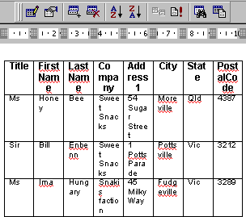
The Data Source can be manipulated as in any table.

Rename Fields

- Click on the Manage Fields button

The Manage Fields dialog box appears. Here we can add new fields, delete fields, or rename existing fields.

We will Rename Address1 as Address, and PostalCode as Postcode

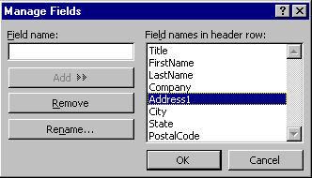
- Click on Address1

- Click on the Rename button

- Type Address in the New field name box

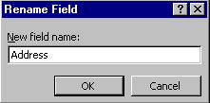
- Click on OK

A prompt will alert you to the problem that Address1 was used in the Main document but no longer exists in the Data Source, we can solve this by simply replacing it with Address as it is now known.
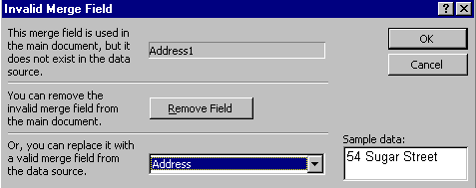
Click here to select Address

- Click into the lower box and select Address to use it as the merge field
- Click on OK

- Repeat the process to Rename PostalCode as PostCode

Adding New Fields

A data source is made more valuable if you regularly update and maintain the records it contains. We can add and delete records, and add and delete fields.
With the Big Top Events data we want to add the new fields

- Product
- Exhibit City
- Site No
- Site Fee

With the Data Source file still open

- Click on the Manage Fields button to display the Manage Fields dialog box

- Type Product in the Field Name box

- Click on the Add button

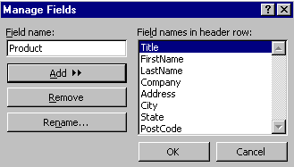
The field will be placed the list

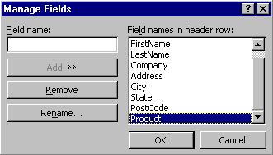

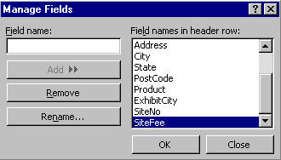
- Repeat the procedure to add the other new fields

- Exhibit City
- Site No
- Site Fee

- Click on OK when finished

The Data Source will look very crowded. However, do not be concerned with its appearance. The data source is never on show to others and the Data Form view of the data source can be used to enter new data.

You can add new information in Data Form view or Source view, however it is much simpler in Data Form view, particularly if you are working with a large number of fields.

- Switch to Form view by clicking on the Form View button

Form View

- Add the following data for Product, Exhibit City etc., to existing records with new fields

Title | FirstName | LastName | Product | ExhibitCity | SiteNo | SiteFee
Mr | Joh | Peanutson | Peanut Snacks | Brisbane | 127 | 500
Mr | Sam | Toucan | Breakfast cereals | Melbourne | 185 | 535
Ms | Honey | Bee | Snack Food | Brisbane | 154 | 450
Ms | Ima | Hungary | Chocolate Bars | Melbourne | 143 | 520
Ms | Nikki | Tarna | Sultana Snacks | Melbourne | 132 | 460
Sir | Bill | Enbenn | Health Seeds | Melbourne | 144 | 500
Miss | Sweeti | Pye | Pies and tarts | Melbourne | 150 | 600
Mr | Tom | Thumb | Fruit Pies | Sydney | 100 | 450

- Click on OK when all the new data is added

- Save and Close the Data file

- Save and Close the Main document file

Using an Existing Data Source

As with the main document the data source can be created within the Mail Merge process, or we can use the data source that already exists.

We will use the data source that has already been set up to send a notification of Site number and Site fee.

- Start a New document and enter the following text

Big Top Events

Dear

Re : The Big Show

Thankyou for confirming your participation in this fantastic event. I’m sure you won’t regret it.

Your company has been allocated site number . The fee for the site is $ . Payment is required by May 1st to confirm your attendance.

If you require further details please don’t hesitate to contact my assistant, Zepo, on (03) 1234 5678.

Yours truly

Bozo Clowning
Marketing Director
Big Top Events

- Click on Tools ➢ Mail Merge in the Menu bar
- Click on Create ➢ Form Letters
- Click on Active Document
- Click on Get Data ➢ Open Data Source

The Open Data Source dialog box appears as shown on the following page.

The Open Data Source dialog box is very similar to the normal Open file box.

- Click on the Look In box and select the 3 ½ Floppy (A:)

- Click on Big Top Data and click Open (you created this data file earlier)
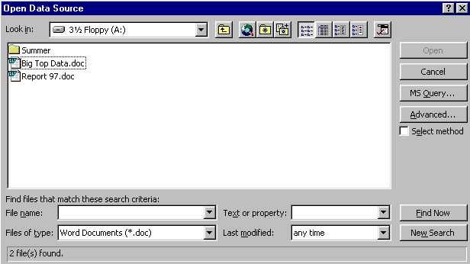
The data source will be open unseen in the background. The main document will still be active on the screen. You will be prompted to insert the merge fields into the document.

- Insert the Merge fields as displayed below – including Site No and Site fee

The document can now be merged as normal.

Big Top Events

´Titleª ´FirstNameª ´LastNameª
´Companyª
´Addressª
´Cityª ´Stateª ´PostCodeª

Dear ´FirstNameª,

Re : The Big Show

Thankyou for confirming your participation in this fantastic event. I’m sure your won’t regret it.

Your company has been allocated site number ´SiteNoª. The fee for the site is $ ´SiteFeeª. Payment is required by May 1st to confirm your attendance.

Create Mailing Labels

We can use the same data source to create mailing labels to send the letters with.

- Click on Tools ➢ Mail Merge to display the Mail Merge helper

- Click on Create ➢ Mailing Labels
Mailing Labels
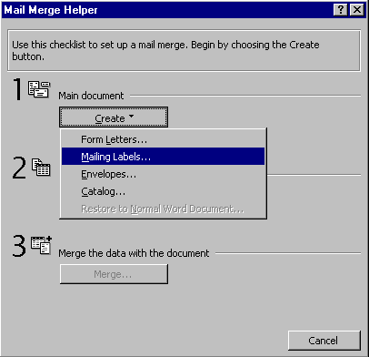

- Click on New Document

- Click on the Get Data ➢ Open Data source

- Select the Big Top Data file and click on Open

A prompt will appear to Set Up Main Document

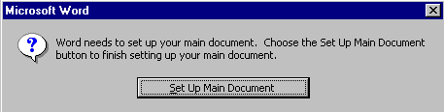
- Click on the Set Up Main Document button

The Label Options dialog box will appear as shown on the following page.

The Label Options dialog box will appear. This enables you to pick exactly which labels are being used. The Avery products of adhesive mailing labels are listed with size codes. If you have another brand that is not included you can find one that is close by using the Details of a label to check which is the closest.

- Scroll down and select 5660

- Click on the Details to show the details for the labels as shown below
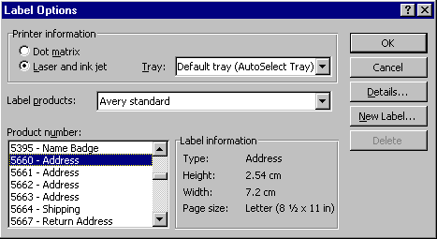
Scroll here to select the label

The Details window can help determine if you have the correct labels

- Click on OK to close and return to the Label Options
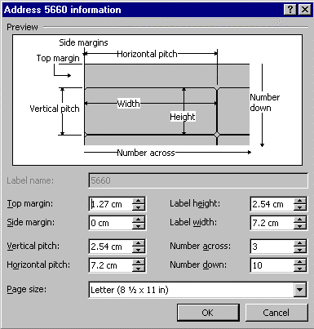
- Click on OK

The Create Labels window appears to set up the layout of the Mailing Label.

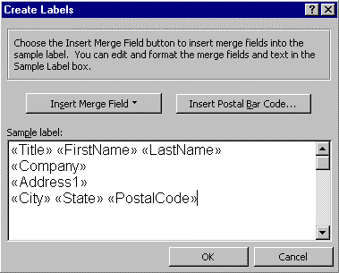
- Click on the Insert Merge Field button

- Click on Title

- Press the [Space] bar

- Click on the Insert Merge Field button again

- Click on FirstName

- Press the [Space] bar again

- Repeat to set up the label as shown to the right

- Click on OK when finished

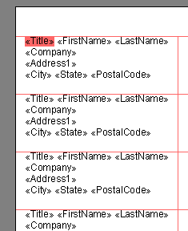You will be returned to the Mail Merge Helper – in the background the mailing labels will be set up according to the Labels you chose

- Click on the View Merged Data button to see what your labels will look like when printed

Create Envelopes

The Envelope feature is available to print names and addresses directly onto envelopes placed in the printer tray. Using the Envelopes feature of the Mail Merge Helper enables you to print an envelope for each record in a data file.

- Click on Tools ➢ Mail Merge to display the Mail merge helper

- Click on Create ➢ Envelopes

- Click on New Document

- Click on Get Data ➢ Open Data source

- Click on the Big Top Data file and click on Open

A prompt will appear to Set Up Main Document

- Click on the Set Up Main Document button
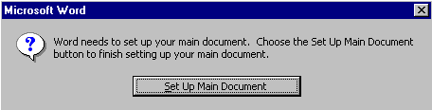

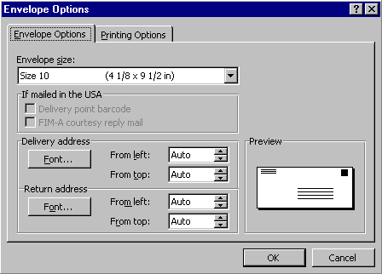
- The Envelope Options dialog box will appear as shown below, click on OK
Printing Options
Choose size
Choose font

- Click on the Insert Merge Field button and select Title

- Continue to place the other fields as shown below

- Click on OK when finished
Insert Merge Field
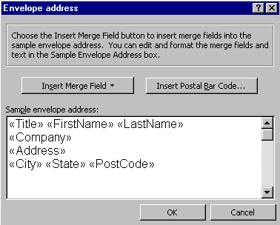

- Click on Close to close the Mail Merge Helper

The envelope will appear on the screen with the positioning of the address.
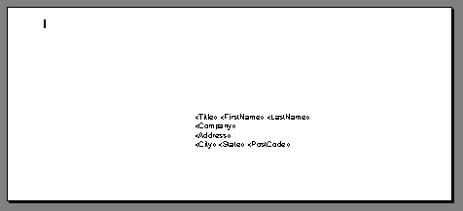

- Click on the View Merged Data button to display the actual text

- Close file without saving

Single Envelopes

If you want to print just one address on one envelope then use the Envelopes and Labels function on the Tools menu rather than going into Mail Merge.

- Start a New document

- Click on Tools ➢ Envelopes and Labels in the Menu bar
- Click on the Envelopes [Tab]

(NOTE: If your dialogue box does not look the same as shown below then click on Cancel – start a New document and start again)

- Type the address in the Delivery Address box
Envelopes
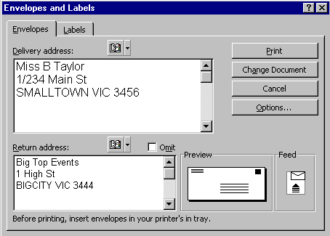
Delivery Address
Return Address
Preview
Feed
Options

The Preview indicates where the text will be located. The Feed area indicates how MS Word expects the envelope to be fed through the printer.

- Click on Options to display the choices available for printing

- Click on OK to close the Options

- Place envelope in printer tray and click on Print to print the address

Single Labels

If you want to print a whole page of the same labels then use the Envelopes and Labels function.

- Click on Tools ➢ Envelopes and Labels in the Menu bar
- Click on the Labels tab
- Type the address in the Address box
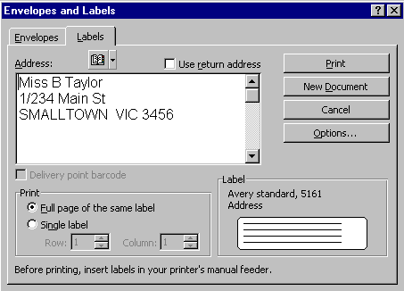

Labels tab
New Document

- Check that Full page of the same label is checked

- Click on New Document

Word will display how the labels will look when printed.

To Print a Single Label in a specific location

- Click on Tools ➢ Envelopes and Labels

- Click on the Labels tab

- Type the Name and Address in the Address box
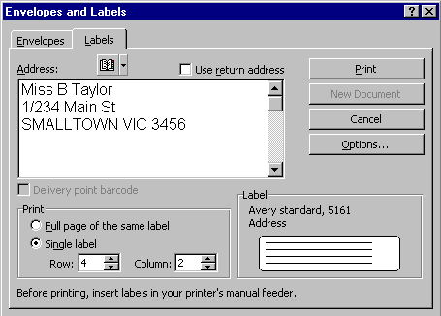
Row
Column

- Click on the Single Label option
- Enter which Row and Column the label is in
- Put the Label paper in the printer tray
- Click on Print

The name and address will be printed on the specified label.

- Repeat the process to print a name and address on labels in the following locations

- Row 1, Column 2
- Row 2, Column 2
- Row 3, Column 1
- Row 4, Column 1

Practice Exercise:

In this exercise you are to create a standard letter to be sent to all entrants in a competition that your company held recently. You will enter the entrants details into a data source because you will use them in the future for direct advertising to these entrants.

8.1 Create the Main Document

- Start a New document and enter the following text
- Start the Mail Merge process using this document as the Main document

Club Holiday Resorts
1 Riviera Drv Port Backwater Vic 3876

Dear

We are sorry to inform you that the terrific prize of two weeks at Club Holiday was won by Ivan Itchyfoot of Sleepy Hollow. However you have won the consolation prize of a day at the Club Holiday resort where you can partake in all the great facilities the resort has to offer. Tennis, golf, 3 course luncheon, spa and swimming, bike and trail rides to mention just a few. You will receive more details about this fantastic day shortly.

Your sincerely

Billy Brazen
Managing Director

8.2 Create a Data Source

- Create a Data Source using the following data – Save it with the name Prospects

Title | First Name | Surname | Address | Town | Post Code
Mr | John | Jones | 1 Gull Crt | Finch | 3145
Ms | Jane | Wills | 10 Hope St | Finch | 3145
Mr | Tim | Fyne | 45 Just St | Elton | 3654
Mrs | Ellen | Allen | 10 Benn St | Elton | 3654

- Insert the Fields in the appropriate positions on the Main document letter

8.3 Merge the Document

- Merge the Prospects Data Source and the Main Document to a file called Unlucky

8.4 Use the Data Source for another Mail Merge

- Create the following invitation, save it with the name Invitation

Club Holiday Resorts
1 Riviera Drv Port Backwater Vic 3876

Dear

We have organised a fantastic day for you at the Club Holiday resort. You can partake in all the great facilities the resort has to offer. Tennis, golf, 3 course luncheon, spa and swimming, bike and trail rides to mention just a few.

This fantastic day is set for [Enter Date here]. It would be great to see you around 9 am so you get the maximum benefit from the day. We will meet you at the Main Foyer then to show you around.

Looking forward to a great day!

Billy Brazen
Managing Director

8.5 Add a New Field to the Data Source and Merge

- Add a New Field to the Data Source

Title | First Name | Surname | Visit Date
Mr | John | Jones | 13 November 1999
Ms | Jane | Wills | 13 November 1999
Mr | Tim | Fyne | 20 November 1999
Mrs | Ellen | Allen | 20 November 1999

- Insert the fields in the appropriate positions in the invitation
- Merge the Invitation Main Document with the Prospects Data Source

8.6 Create a Set of Mailing Labels from the Data

- Create Mailing Labels from the Data Source

